EAPS 431 - Lab #1

I calculated the density using the Ideal gas law equation. I made a new column with the correct units for temperature (to Kelvin) and pressure (to Pascals) and then calculated using the columns and features in excel (assuming dry air). I didn’t think I needed to change the units for the height. I then made graphs using excel. My density vs pressure graph looks just fine, but my density for temperature graph looks very concerning because it doesn’t make sense. I would like to note that I deleted the last two rows of the data because for some reason they had peculiar points (like -9999 etc.).

Figure 1: Density VS Pressure

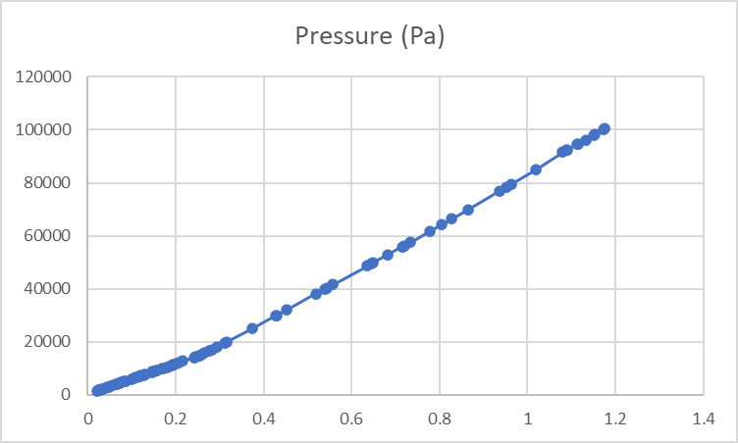

Figure 2: Density VS Temperature

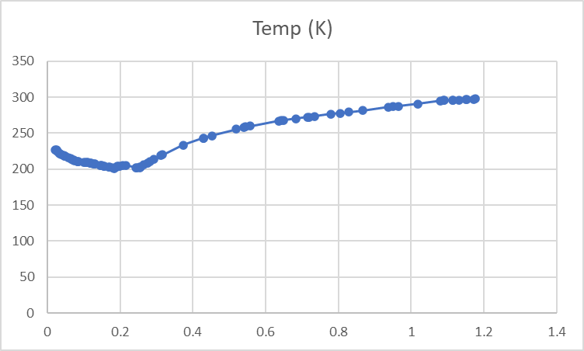

Figure 3: Density VS Height

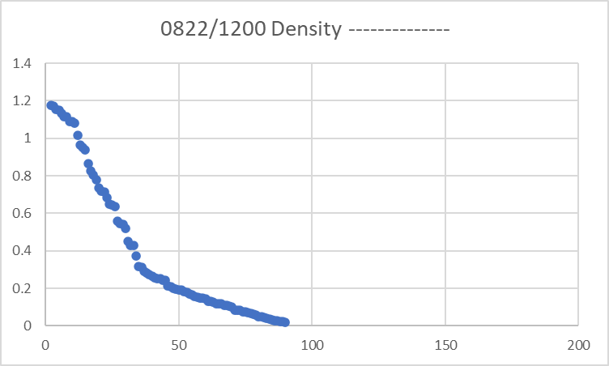

In figure 1, it shows (correctly) that density and pressure have a positive relationship. However, figure 2 just seems confusing and doesn’t make sense to me. It doesn’t make sense because the part of the graph where the line is decreasing makes sense because the relationship between density and temperature is inverse (telling from the equation). However, then it shows a positive rate of change, which is odd.

Finally, my third graph was a plot of the Density VS Height. This graph makes perfect sense. The density decreases with increasing height (an inverse relationship) at a nonlinear rate.

I would like to note that I’m not good with excel and don’t know how to change the title. I would also like to note that the lab report was given on bright space and talks about groups, I just did this by myself. I don’t know if we had groups. I apologize for any inconvenience that I might’ve caused.

I then plotted Temperature VS Pressure (Figure 4) and Temperature VS Height (Figure 5) and got some interesting plots.

Figure 4: Temperature VS Pressure

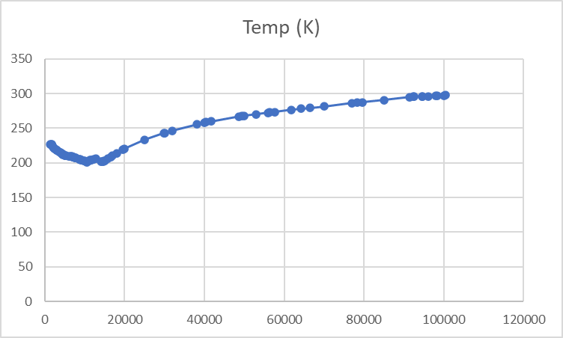

Figure 5: Temperature VS Height

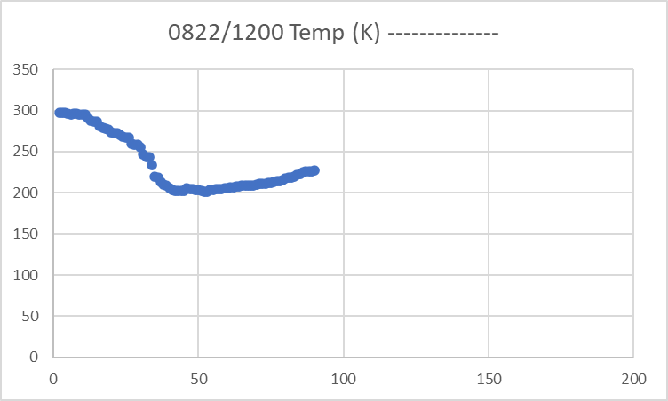

My temperature vs pressure graph (Figure 4) looks exactly like my density vs temperature graph (Figure 2) which is concerning. I think there might be something wrong with my data, but I’m not sure where it is. Either that, or I might have done something wrong when make the graphs.

Upon further inspection of Figure 5, it also looks wrong, but at least is a little better than Figure 4. It shows a decrease of temperature and then an increase, which makes sense.

I plotted one more graph, just so that I end on a good note. I plotted Pressure vs height (figure 6). The plot makes perfect sense and looks just fine.

Figure 6: Pressure VS Height

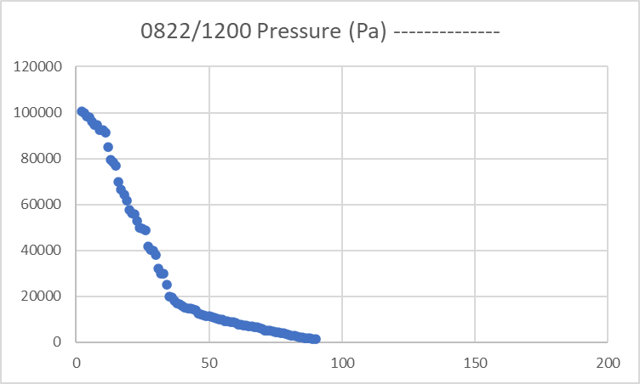

Finally, since I didn’t work with the lapse rate throughout the entire lab, I decided to do a lapse rate calculation at the end. I calculated the lapse rate between the 700Mb level and the 500Mb level which have temperatures of 8.4 degrees C and -5.1 degrees C respectively. However, before I calculate, the lapse rate is shown below (picture 1) and the correct units need to be used. To change Mb to Pascals, multiply by 100 and to change from degrees C to Kelvin, add 273.15. The work is shown below.

Picture 1: Lapse rate equation ([link](https://wingsofaero.in/calculator/lapse-rate-calculator-by-mohit-kudal/) to the picture)

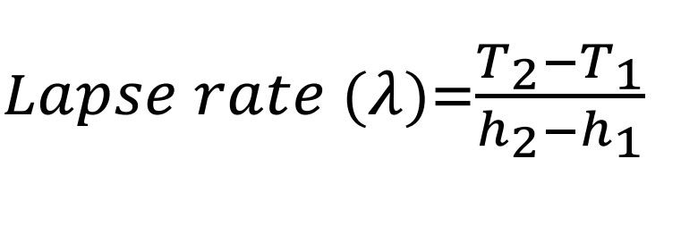

Picture 2: Work to find the lapse rate between 700Mb level and 500Mb level

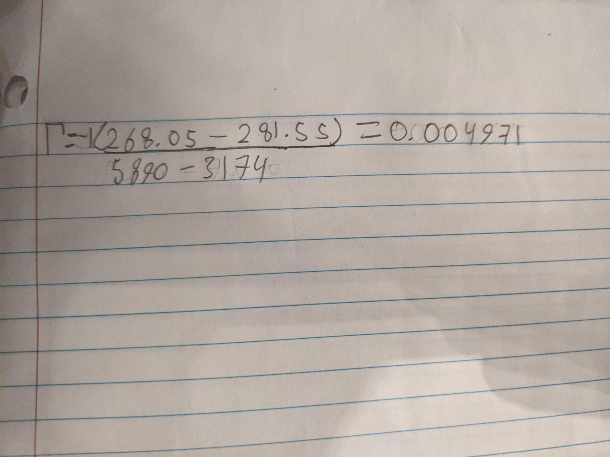

This answer makes sense. It means that the temperature is decreasing with height.